Docker Setup
- Install Docker to your Machine
  - Navigate to https://docs.docker.com/desktop/release-notes/ and download the latest version of docker for your machine as well as the checksums file.
    - Verify the install with the provided hash.
      - MacOSX
        - Open a new terminal window (CMD + SPACE)
        - Type in the following: “Terminal” and open this executable
        - Navigate to the Downloads folder.
          - In Terminal enter: “cd” This will take you to your User account level.
          - Enter: “cd Downloads”
          - Enter: “sha -a 256 Docker.dmg”
          - Enter: “cat checksums.txt”
          - Compare the hash file to the hash file provided on https://docs.docker.com/desktop/release-notes/. If the hash files are not identical DO NOT INSTALL
          - A verified download should look like the following: 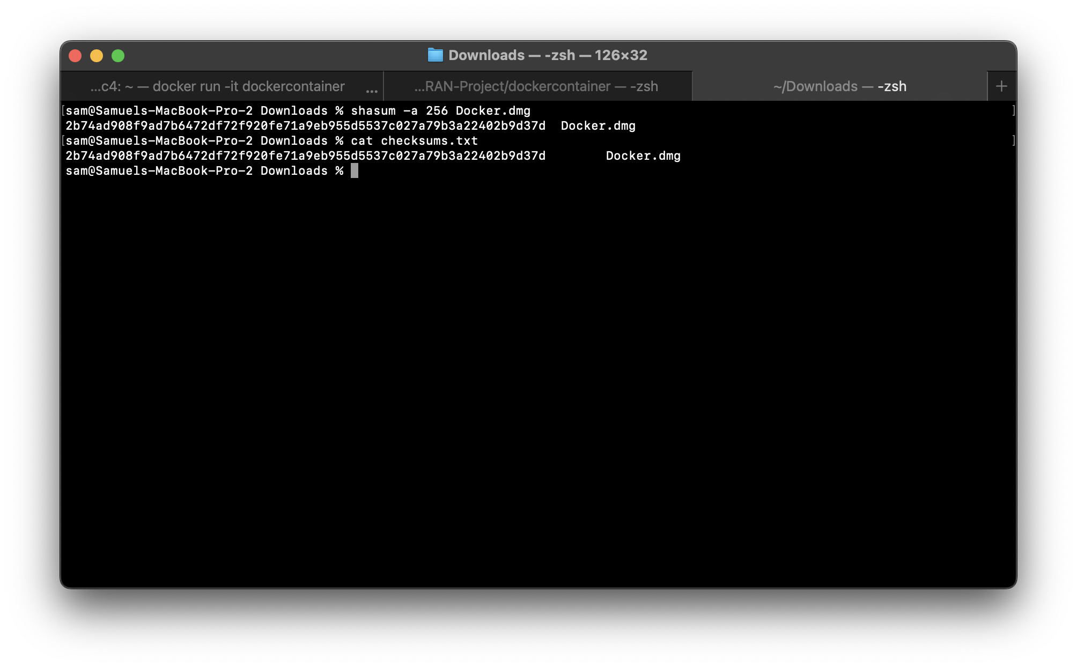
      - Windows
      - ED
    - After successfully obtaining a safe install of Docker you may continue.
  - Navigate to your downloads folder and open the Docker Install.
    - MAC OSX
      - Open the Docker.dmg file and follow the install.
      - Open Docker on your local machine.
      - When asked to login you may skip this step by clicking “skip Login”
    - Windows
    - ED
- asdf

